**Resources from** “**Discovering and Sharing Your Working Lands Story”**

**Tuesday, Oct. 1 • Jordan MT**

**Suzi Taylor, MSU Science Math Resource Center / Montana NSF EPSCoR**

This document includes some references and resources that will help you think strategically about how to construct positive messages for your organization or your work; how to structure those messages into a STORY; and how to flesh out that story with elements that make it “stick.”

We can **frame our messages** by first studying public misperceptions ([Frameworks](https://www.frameworksinstitute.org/) Institute calls this the SWAMP) then re-framing our messages into positive statements.

Case studies: This organization wanted to counteract negative messages with positive messages about suicide prevention.

<http://suicidepreventionmessaging.org/narrative>

<http://suicidepreventionmessaging.org/>

Reporting_on_Suicide.pdf

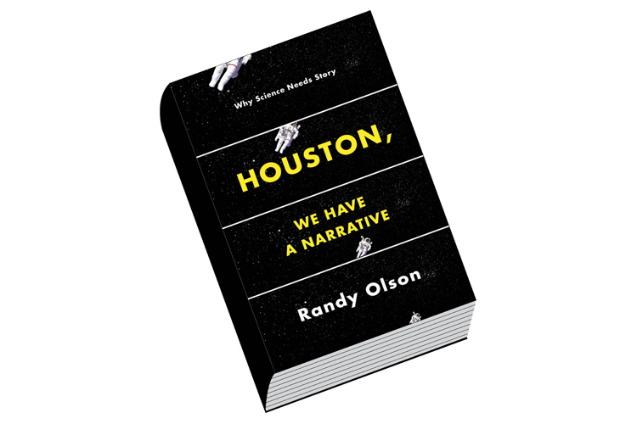**ABT**

Randy Olson shares the “And, But, Therefore” infrastructure for storytelling in [Houston, We Have a Narrative](http://scienceneedsstory.com/). Olson doesn’t claim to have invented this – it goes back to ancient mythology and Joseph Campbell’s hero’s journey. South Park creators told it to Olson.

All great stories have this infrastructure:

\_\_\_\_\_\_\_ AND \_\_\_\_\_\_\_\_, BUT \_\_\_\_\_\_\_\_\_\_, THEREFORE \_\_\_\_\_\_\_\_\_\_.

You may use different words, such as *yet* and *so*. You might not even use these words at all if the ideas are conveyed. The first one doesn’t need to have an AND (or it can have more than one AND); this is just the part that sets the scene for your situation.

Too many stories are AAA, not ABT. They are just *This happened and this happened and this happened…..*with no problem/situation (BUT) or resolution (THEREFORE).

You can practice finding the ABT in movie plots, press releases, and radio news stories.

*A little girl was living in Kansas* ***and*** *her life was boring,* ***but*** *one day a tornado sweeps her away to the land of Oz,* ***therefore*** *she must undertake a journey to find her way home.*

*Pallid sturgeon are large-bodied fish* ***and*** *they have lived in Montana’s Missouri River for millions of years,* ***but*** *in just two generations, human impacts have put them at the brink of extinction.* ***MSU researchers are studying*** *how to rebuild the population.*

Not every form of communication has to be a STORY. Sometimes we are just communicating information, such as a press release about an event. But, when we DO tell a story, this framework will make sure the required elements are in place. From here, we can start adding the detail and emotion and factoring in the audience.

The [Message Box from COMPASS](https://www.compassscicomm.org/the-message-box-workbook) brings in the audience and more detail to the ABT, such as the “So What?” and the “Benefits” along with the AND (Issue), BUT (Problem) and THEREFORE (Solution). (You can download a blank box and full workbook at the link)

messageboxfull.tiff

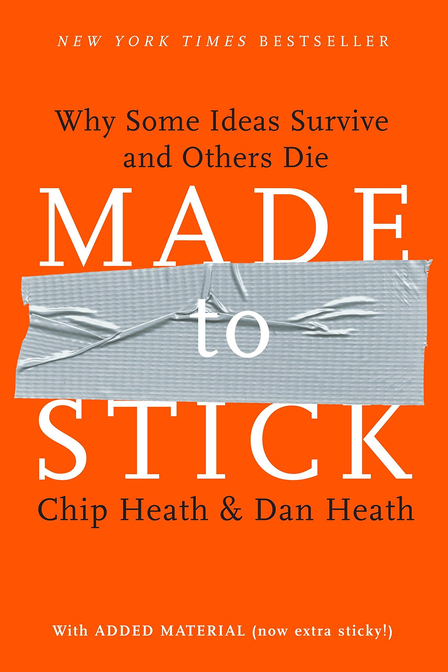 [Made to Stick by Chip and Dan Heath](https://heathbrothers.com/books/made-to-stick/) offers six key elements that make stories memorable. (The website above has lots more great resources, including **Presentations that Stick** and **Teaching that Sticks**)

Good, memorable stories are:

* **Simple** – People can’t handle too much info at once. Give them ONE THING to remember (photo of messy store – what do you focus on?)
* **Unexpected** – What is counter-intuitive about your message? (Carli Lloyd soccer player trying out for the NFL; NFL player missing a 34-yard field goal; Deodorant ad making fun of that kicker)
* **Concrete** -- Give details that help people picture the story
* **Credible** – use your personal experiences. Statistics can help, but not too many
* **Emotional** – Make people care! Connect something they don’t yet care about to something they do care about (e.g., may not like golf but appreciate the bonding of a grandson and grandfather on the golf course)
* **Stories** -- Stories are personal. Stories have a beginning, middle and end. People respond better to positive stories.
  + A *credible* idea makes people *believe*.   
    An *emotional* story makes people *care*.   
    The *right* stories make people *act*.

Stories of individuals are better than of a group (e.g., TV ads ask you to donate to ONE child, THIS child).

People gave more money for a water filtration system that helped 4,500 out of 11,000 people rather than 4,500 out of 250,000 people. Even though it’s the same number of people helped, their help seems significant, whereas saving a small proportion seems like a failure, even if it’s a high number.

Readers didn’t want to hear stories about AIDS – the topic was so vast and catastrophic and depressing that they couldn’t handle it. “One death is a tragedy. A million deaths is a statistic.”

See “Nicholas Kristof’s Advice for Saving the World” <https://www.outsideonline.com/1909636/nicholas-kristofs-advice-saving-world>

A few more resources:

* [Cause Communications](http://causecommunications.org/)
* [Spitfire Strategies](https://www.spitfirestrategies.com/tools/) (sign up for Spitfire Sparks newsletter; download other tools)
* [The Goodman Center](https://www.thegoodmancenter.com/) (Free Range Thinking newsletter and other free downloads)

**Suzi Taylor**

**Director, MSU Science Math Resource Center**

**Outreach team, Montana NSF EPSCoR**

[**www.montana.edu/smrc**](http://www.montana.edu/smrc)

[**taylor@**](mailto:taylor@)[**montana.edu**](mailto:taylor@montana.edu)