Ranchers Stewardship is hosting:

Low Stress Livestock Handling Workshop

Featuring Tom Curtin

Tom has taught horsemanship clinics for over 20 years. This coupled with his knowledge, ownership and handling of livestock provides Tom with the tools to teach others something he is very passionate about. Tom has been fortunate to be around and work for some of the most famous ranches of the west. Through his experience and experimentation Tom feels that the combination of his horsemanship knowledge joined with his stockmanship skills could help both the small operation and or the large ranch. Tom is certified by the Beef Quality Program (BQA). BQA has an educating program that helps producers identify management processes that can be improved.

Wednesday, November 13th , starting at 10 a.m. at the Milk River Pavilion, Malta MT

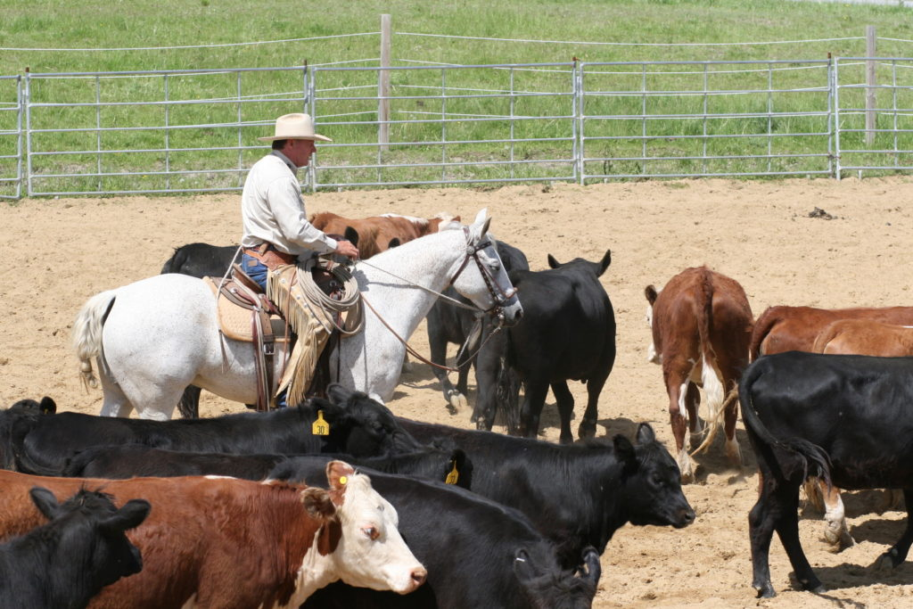

Registration Fees:

Preregistration fees are until Nov. 6th:

Adults – For each ranch or business: 1st person is $60, each additional is $40.

Students - $30 each

Registration from Nov. 7th and at the door:

Adults – For each ranch or business: 1st person is $75, each additional is $55.

Students - $35 each

RSA thanks sponsors: Montana FFA Foundation and Boerhling

A $8 lunch will available by the Malta FFA Chapter.